*05.12.2021*

**

**MIDDLE EAST TECHNICAL UNIVERSITY**

**Electrical & Electronics Engineering Department**

**EE493 - Engineering Design I**



***Detection Subsystem Research Notes***

1. **INTRODUCTION**

The project to be implemented, “Cısss!” has many subsystems, but the detection subsystem may be the most important of them all. As such, this file will present the findings of the research done. You will find the brainstormed ideas as well as some implementation proposals that are to be discussed in the following weeks.

The detection subsystem is tasked with detecting whenever the master unit enters the range of the tags. Furthermore, it is desirable that it is able to detect how far the master is from the tags and with as high resolution as possible. Researching examples of such implementations, this document was created to log possibly useful information and ideas for future reference.

1. **ELECTRONIC ARTICLE SURVEILLANCE**

Electronic Article Surveillance, or EAS as it will be referred to from now on, is a method used to prevent shoplifting. It is now the norm for stores to install EAS. EAS may be implemented in many different methods, some of which will be expanded upon, but the most common practice is to install a detector to the possible exits of the store, which rings an alarm if it senses a tag; tags that are attached to the merchandise by the store which are taken out during check-out. The similarity between the project to be implemented and this is striking. Some of the common methods used include electromagnetic (EM), acousto-magnetic (AM), and radio frequency (RF) sensing.

EM sensing utilizes magnetization. Using metglas which has a very low magnetic saturation value, the detection is achieved by the material’s response to low-frequency magnetic frequency. This method’s advantage is that it can be implemented with small objects or have foil packaging. It is also used in confidential papers, where papers with embedded microwires are utilized to prevent intellectual theft. Deactivation is achieved by magnetizing the tag.

The AM method utilizes ferromagnetic amorphous strips. The detector emits waves with the same resonant frequency as the strips. When the waves hit the strip, it causes a vibration, which changes the magnetization of the strip. This causes the strip to create an induced voltage in the detector.

The RF method uses an LC circuit, whose resonance frequency is usually in the 1.75 to 9.5 MHz range, though typically 8.2 MHz is utilized in retail stores. The detector senses the tag's presence by emitting waves that sweep around the resonance frequency of the tag, and sensing the dip. This method is the most preferred method due to its easy deactivation.

EAS is useful for detecting whenever the tag enters the range, but other methods may be needed for detecting how far the tag is from the master, as this method’s intended usage is not to do that.

1. **RADIOFREQUENCY IDENTIFICATION (RFID)**

Radio Frequency Identification (RFID) is a method of tracking an object through the use of electromagnetic waves. Used in various fields, RFID operates with tags that help identify the object that is being looked for. Tags may be active or passive. Passive tags do not need an external battery and are instead powered by the radio waves emitted by the master. On the other hand, active tags are powered up by batteries, which allow them to have better performance than passive tags.

We would prefer our tags to be passive in the project, as inserting a battery into every tag would be tedious for the customer. However, if a passive implementation does not have the performance wanted, active tags may be used as well.

RFID tags consist of three parts: a microchip, a transceiver and a substrate. They can be passive, active, or battery-assisted passive. An active tag has an onboard battery and periodically transmits its ID signal. A battery-assisted passive tag has a small battery on board and is activated when in the presence of an RFID reader. A passive tag is cheaper and smaller because it has no battery; instead, it uses the reader’s radio energy. However, a passive tag must be illuminated with a power level roughly a thousand times stronger than an active tag for signal transmission to operate ‘t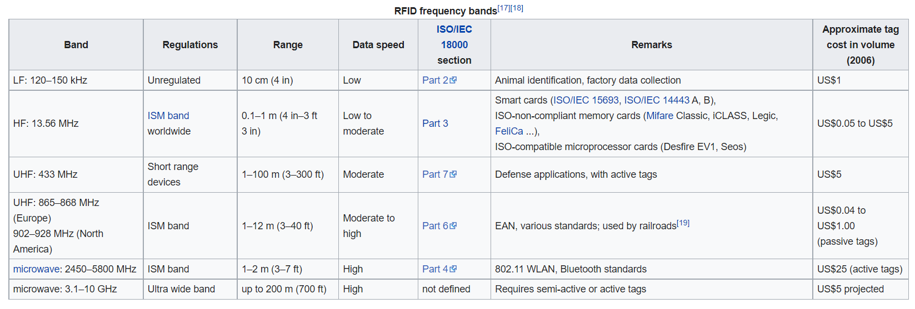

Figure I: Table (taken from Wikipedia) showing different RFID frequency bands and their typical characteristics.

1. **COMMON PROXIMITY/DISTANCE DETECTION METHODS**

Proximity and distance detection may be mixed up, and while they are similar, they are not the same. Proximity detection detects whether an object is in the area of detection, while distance detection detects how far the object is. While we definitely need proximity detection, we also want distance detection in our project.

Some of the common proximity detection methods include inductive, capacitive, ultrasonic, and infrared (IR). Inductive and capacitive are usually used for touch detection implementations and have a very short range for our implementation. Ultrasonic and IR on the other hand may be used.

Ultrasonic sensors emit ultrasonic waves, as the name implies, which hit the target and then bounce off, and then the time it takes for the emitted waves to return can be used to compute the distance. Its advantage is that it is not affected much by external factors; furthermore, it is also used commonly in distance detection. Also, it has low power consumption. Its disadvantage is that while it has a much better range than inductive/capacitive sensing methods, its range is still limited.

IR sensors emit infrared light through an LED, which hits the target and is reflected in an angle. When the reflected light reaches the sensor back, its position can be determined by the sensor. This method offers angular detection as well (detecting the angle between the master and the tag), but this is not very useful in our case. Its main advantage is that its accuracy is not affected through usage and offers a very good range in its line of sight. Furthermore, like ultrasonic sensing, it can be used for distance detection, although the accuracy of distance detection drops in long ranges. However, the detection is limited to its line of sight only, which may be a major problem in the house where there are many objects. Furthermore, it has a higher power consumption compared to ultrasonic sensing.

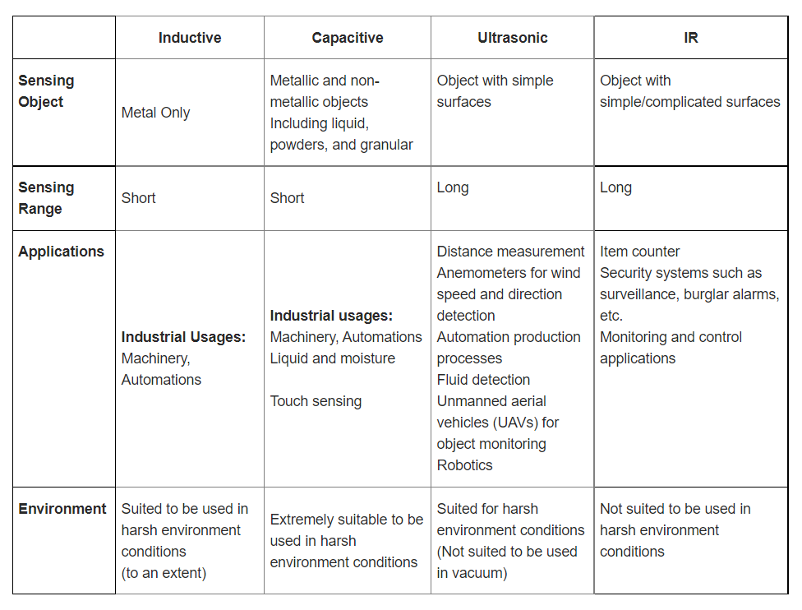

Figure II: Table comparing different methods for proximity detection

Some of the common distance detection methods include ultrasonic and infrared sensing as mentioned before, as well as other methods such as time of flight (ToF) and light detection and ranging (LIDAR). LIDAR detection uses laser rays reflected by the tag and the time it takes for the reflection to be complete to calculate distance. LIDAR detection is very accurate at detecting even small tags. However, it is also costly. ToF is similar to LIDAR in working principles. It emits wave pulses that reflect off the object to be detected, and the time it takes for the waves to come back to the sensor (time of flight) is used to compute distance. It has a good detection range and accuracy, although it is a bit more costly than other methods, except for LIDAR.

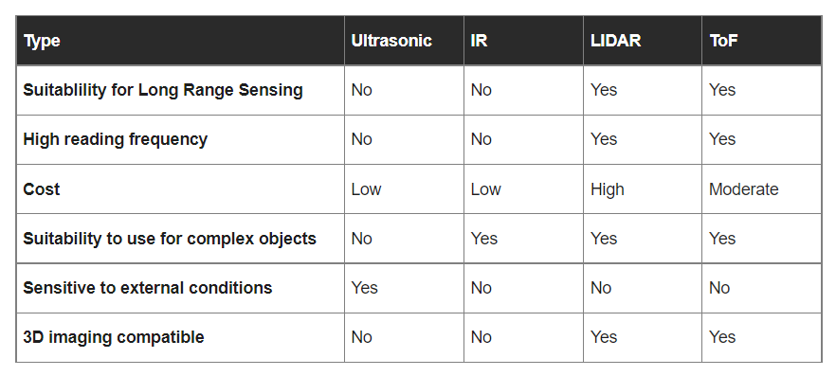

Figure III: Table comparing different methods for distance detection

1. **REFERENCES**

<https://en.wikipedia.org/wiki/Radio-frequency_identification>

<https://en.wikipedia.org/wiki/Electronic_article_surveillance>

<https://losspreventionmedia.com/which-electronic-article-surveillance-technology-is-your-best-defense-against-shrink-am-rf-or-rfid/>

<https://www.seeedstudio.com/blog/2019/12/23/distance-sensors-types-and-selection-guide/>

<https://www.seeedstudio.com/blog/2019/12/19/all-about-proximity-sensors-which-type-to-use/>

<https://en.wikipedia.org/wiki/Real-time_locating_system>

<https://en.wikipedia.org/wiki/Received_signal_strength_indication>

<https://en.wikipedia.org/wiki/Automatic_identification_and_data_capture>

<https://www.diva-portal.org/smash/get/diva2:1282151/FULLTEXT01.pdf>